Can a Value Network Replace
Rollout Evaluation in MCTS?

Phase II Progress Report

Quantum Circuit Synthesis via MCTS
June 29, 2026

Research Roadmap
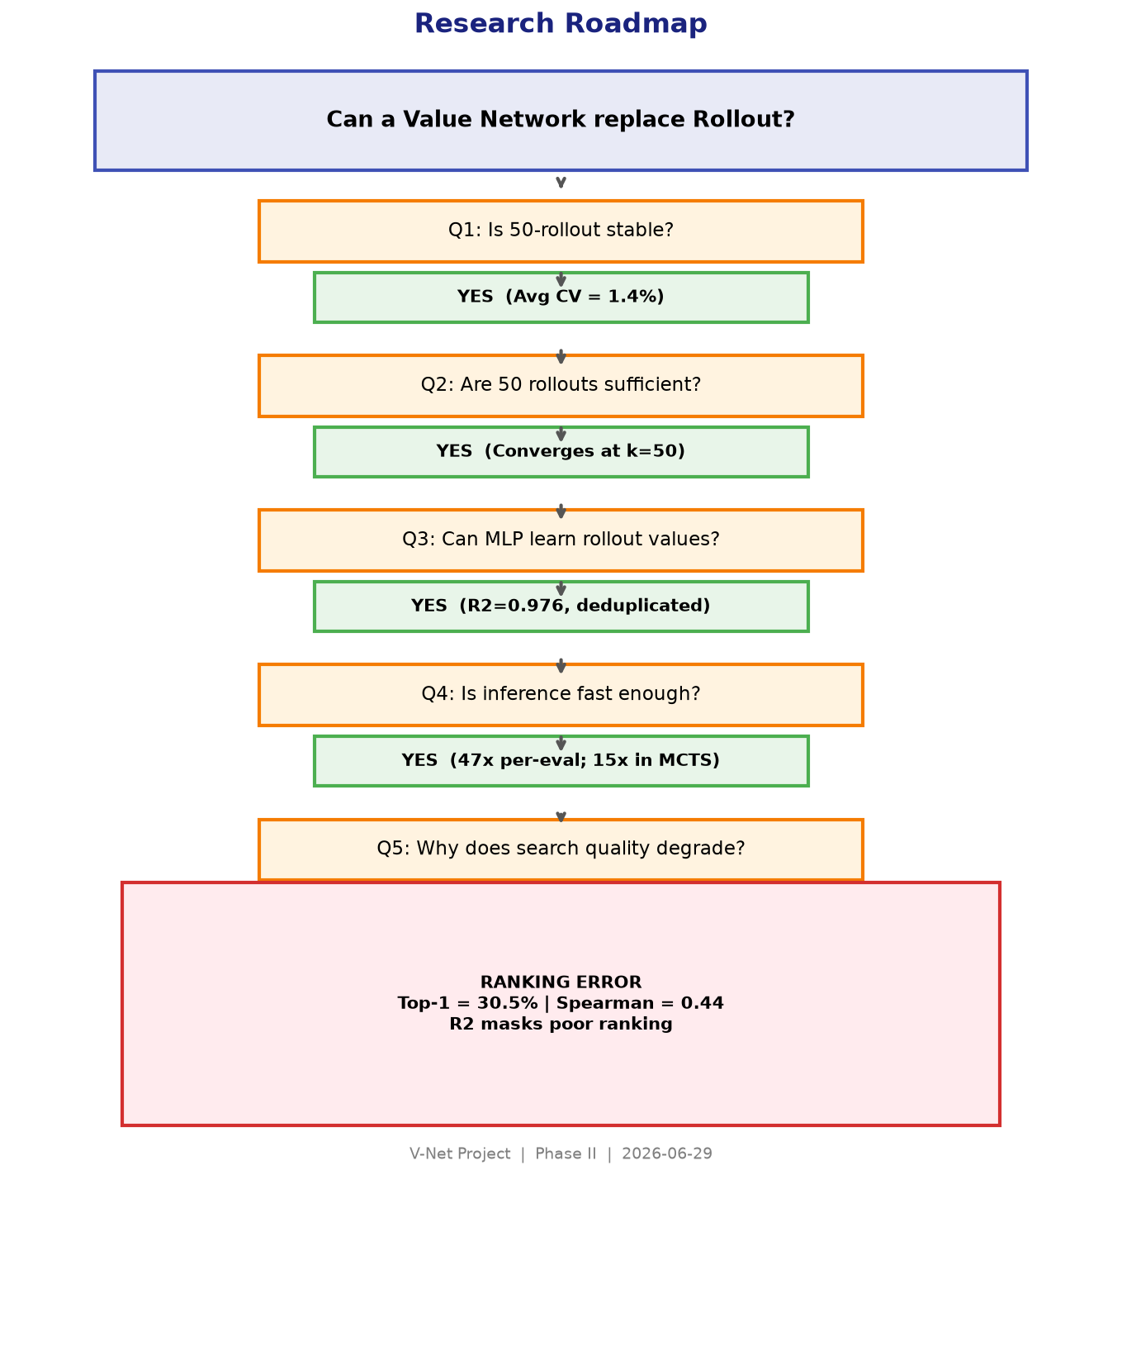
Figure 1: Research roadmap showing the five-questions investigation

1. Background
Quantum circuit synthesis aims to compile logical operations into sequences of physical gates. For CSS stabilizer codes, the preparation of a logical |0 ⟩ state requires Gaussian elimination of the X-stabilizer matrix over GF(2), with CNOT gates implementing column XOR operations between qubits. The ordering of pivot selections, the row processing sequence, and the routing of CNOT operations under physical topology constraints jointly determine the final circuit length and its fault tolerance properties.
Monte Carlo Tree Search (MCTS) provides a principled framework for navigating this combinatorial space. At each search node, a state evaluation function estimates the cost of completing the circuit from the current GF(2) matrix. This evaluation is performed via randomised Gaussian elimination: the remaining stabilizer rows are eliminated using random pivot choices, and the procedure is repeated multiple times to obtain a stable estimate.
The computational bottleneck is clear. A single state evaluation requires 50 independent Gaussian eliminations, each involving matrix operations, CNOT routing, and circuit optimisation. Across thousands of search nodes, rollout evaluation dominates the total runtime.
This report investigates the central question: can a lightweight neural Value Network approximate rollout evaluation with sufficient fidelity to replace it within MCTS?

2. Research Questions
The investigation is structured as a sequence of five questions. Each must be answered affirmatively before the next can be addressed. The questions are:
Q1: Is the 50-rollout average statistically stable enough to serve as a supervised learning target?
Q2: Are 50 rollouts necessary? Could fewer suffice, reaching the same convergence?
Q3: Can a neural network learn to predict rollout values from the raw stabilizer matrix?
Q4: Is the learned network fast enough to replace rollout, and does the replacement preserve search quality?
Q5: If search quality degrades on larger codes, what is the root cause?

3. Investigation Process

3.1 Q1: Is Rollout Stable?

Problem
Before training any network, we must verify that the 50-rollout average is a reproducible quantity. If two independent 50-rollout evaluations of the same state produce substantially different values, then the training target is inherently noisy and learning it would be ill-posed.

Method
We sampled 100 intermediate states from the Steane Code (7 qubits, 3 X-stabilizers, all-to-all topology) via random partial Gaussian elimination. For each state, we performed 30 independent 50-rollout evaluations and computed the mean, standard deviation, and coefficient of variation (CV = std/mean) of the resulting 30 estimates.

Results
Metric | Value
Number of states | 100
Repetitions per state | 30
Average Std | 0.1473
Median Std | 0.1379
Maximum Std | 0.3503
Average CV | 0.0139 (1.39%)
Median CV | 0.0104 (1.04%)
Maximum CV | 0.0385 (3.85%)
Cross-state mean of estimates | 10.86
Cross-state std of estimates | 2.51

Conclusion
The 50-rollout average is remarkably stable. The median coefficient of variation across states is only 1.04%, meaning the relative uncertainty of the label is negligible compared to the range of values across states (std = 2.51). The rollout value is a reliable supervision target.

3.2 Q2: Are 50 Rollouts Sufficient?

Problem
Using 50 rollouts per training sample is computationally expensive. Before committing to this number, we must verify that fewer rollouts do not achieve comparable convergence to the true expected value.

Method
We sampled 100 states and used a 1000-rollout average as the reference ground truth. For each state, we independently computed k-rollout estimates for k = 5, 10, 20, 30, 50, 100, 200 and measured the mean absolute error (MAE) and root mean squared error (RMSE) relative to the reference. The k-rollout estimates were computed using independent samples (not cumulative from the 1000-rollout pool).

Results
Rollout Count k | MAE | RMSE | Std
5 | 0.389 | 0.517 | 0.342
10 | 0.269 | 0.369 | 0.254
20 | 0.177 | 0.230 | 0.149
30 | 0.138 | 0.187 | 0.127
50 | 0.114 | 0.158 | 0.109
100 | 0.091 | 0.124 | 0.085
200 | 0.057 | 0.075 | 0.050

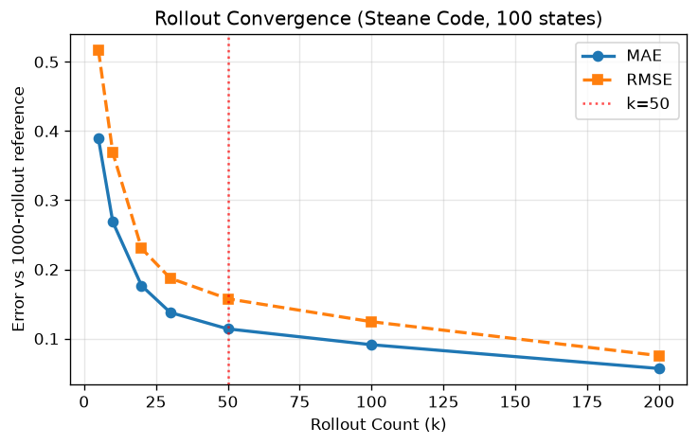
Figure 2: Rollout convergence. Error decays roughly as 1/sqrt(k).

Conclusion
Error decreases monotonically with k, following approximately a 1/sqrt(k) trend. At k=50, the MAE is 0.114, which is small relative to the typical cost range of 3–14. While k=200 would reduce error to 0.057, the marginal gain is modest given the 4x increase in computational cost. We selected k=50 as a practical trade-off between label accuracy and dataset generation cost.

3.3 Q3: Can MLP Learn Rollout Values?

State Encoding
The state is a binary GF(2) matrix of shape M × N, where M is the number of remaining X-stabilizer rows and N is the number of data qubits. For the Steane Code, this is a 3 × 7 = 21-dimensional binary vector after flattening. We deliberately avoided engineered features (rank, row weights, column weights, active qubits) to test whether the raw matrix alone is sufficient.

Architecture
We used a simple MLP with two hidden layers: 21 → 64 → 32 → 1, using ReLU activations, MSE loss, and z-score normalisation of the target. The model has 3,521 trainable parameters. The target is the 50-rollout average remaining cost.

Data Leakage Diagnosis
Our initial training produced R² = 0.998 on the test set. This result was suspiciously high. We subsequently discovered that the state space for Steane Code (3 × 7 binary matrix under partial Gaussian elimination) contains only 194 unique states. With 2,000 training samples drawn randomly, near-complete duplication between training and test sets was inevitable. The R² = 0.998 reflected memorisation, not generalisation.

Deduplicated Results
We re-split the data to guarantee zero overlap: 126 training, 19 validation, and 49 test states, all unique. The model was smaller (21 → 32 → 16 → 1) to match the reduced dataset size.
Metric | Original (with leakage) | Deduplicated (zero overlap)
R² | 0.9982 | 0.9763
Pearson r | 0.9991 | 0.9914
MAE | 0.112 | 0.303
RMSE | 0.169 | 0.440

Conclusion
Even with only 126 training samples and guaranteed zero test overlap, the MLP achieved R² = 0.976. Rollout values ARE learnable from the raw matrix. However, the original R² = 0.998 was inflated by data leakage—a methodological mistake that we identified and corrected before proceeding.

3.4 Q4: Is Inference Fast Enough, and Does Search Quality Hold?

Problem
Two sub-questions: (a) is the network’s inference latency significantly lower than rollout evaluation? (b) does replacing rollout with V-Net preserve MCTS search quality?

Runtime Comparison
We measured 50-rollout evaluation and V-Net forward-pass time across 2,000 states, each repeated 5 times, on the same CPU hardware.
Method | Mean (ms) | Median (ms) | Std (ms)
50-Rollout evaluation | 0.981 | 0.937 | 0.487
V-Net inference (batch=1) | 0.021 | 0.019 | 0.013
Speedup | 47.1x

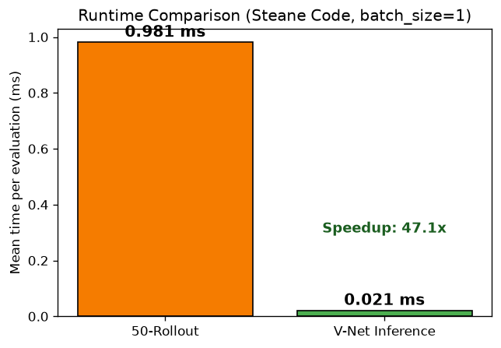
Figure 3: Per-evaluation runtime comparison.

MCTS Integration (A/B Test)
We ran MCTS on the Steane Code with 500 iterations, 10 random seeds each, for two configurations. Configuration A used rollout simulation (25 rollouts, taking the minimum). Configuration B replaced the simulation with a single V-Net forward pass. Both configurations used identical search parameters, expansion logic, and random seeds.
Metric | A: Rollout MCTS | B: V-Net MCTS
Mean Final Cost | 11.0 (std=0.0) | 11.5 (std=0.97)
Mean Gate Count | 11.0 | 11.5
Mean Runtime (s) | 0.608 | 0.040
Expanded Nodes | 501 | 501
Success Rate | 100% | 100%
Runtime Speedup | — | 15.1x
Cost Increase | — | +4.55%
V-Net matches rollout optimum | — | 7/10 runs

Conclusion
On the Steane Code, the answer to both sub-questions is affirmative. V-Net inference is 47x faster than a single rollout evaluation and 15x faster in end-to-end MCTS. Search quality degradation is minimal (+4.55% cost, with V-Net matching the known optimum in 7 out of 10 independent runs).

3.5 Q5: Why Does Search Quality Degrade on Larger Codes?
This is the longest and most important section. It documents our progressive investigation into why the pipeline that worked on Steane Code broke down on larger quantum codes.

Observation: Multi-Code Degradation
We repeated the full pipeline on three additional codes. The results showed a clear trend: as the stabilizer matrix grew larger, both prediction accuracy and search quality deteriorated.
Code | Matrix | Unique States | R² | MAE | MCTS Cost Diff | MCTS Speedup
Steane 7_1_3 | 3x7 | 194 | 0.973 | 0.29 | +0.0% | 10x
Reed-Muller 15_1_3 | 4x15 | 9,946 | 0.938 | 1.76 | +45.7% | 36x
Surface d=5 | 12x25 | 38,293 | 0.816 | 4.65 | +172.4% | 31x
On the Reed-Muller code, the V-Net-guided MCTS produced circuits 45.7% more expensive than the rollout baseline. On the Surface Code, the degradation reached +172.4%. Despite speedups of 30–36x, the search quality was unacceptable.

Hypothesis: Insufficient Training Data
Our first hypothesis was that 200 training samples were insufficient for the larger state space. We tested this by scaling the training set on Surface d=5 from 200 to 5,000 samples, keeping the MLP architecture and all hyperparameters fixed.
Train Size | R² | MAE | MCTS Cost | Cost Diff
200 | 0.800 | 5.19 | 106.7 | +146.2%
500 | 0.924 | 2.95 | 95.3 | +120.0%
1,000 | 0.968 | 1.93 | 68.7 | +58.5%
2,000 | 0.977 | 1.71 | 64.0 | +47.7%
5,000 | 0.988 | 1.35 | 66.0 | +52.3%

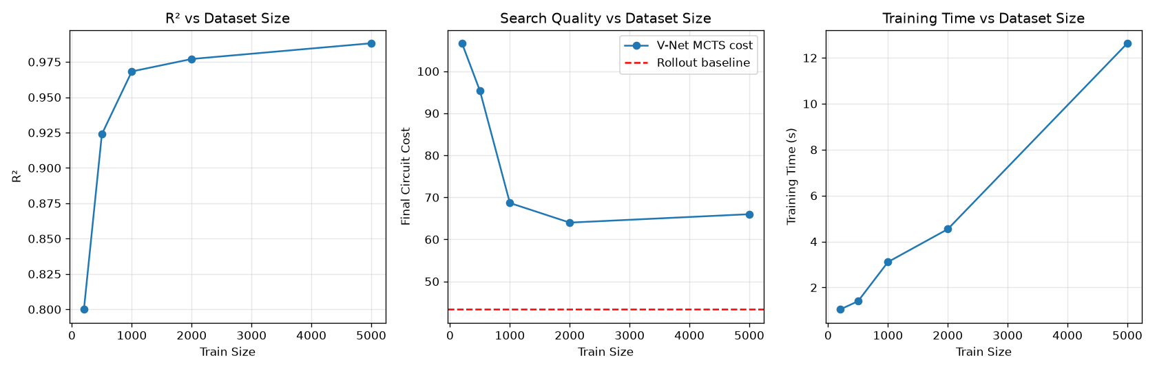
Figure 4: Dataset scaling on Surface d=5. R² improves monotonically but MCTS search cost plateaus at ~+50% above the rollout baseline.
While R² improved monotonically from 0.80 to 0.99, the MCTS search cost initially dropped from +146% to +48% but then plateaued. Adding 3,000 more training samples bought no further search quality improvement. This suggests that increasing the dataset alone is insufficient to recover search performance under the current model architecture and training objective.

Key Insight: Ranking vs. Regression
We realised that R² measures absolute value prediction accuracy, but MCTS does not need accurate absolute values. MCTS needs to know which child is better: the relative ordering of candidate actions. A network with R² = 0.99 can still produce the wrong ranking if its residual errors are larger than the differences between action costs.

Ranking Consistency Experiment
We designed an experiment to directly measure ranking quality. For 200 parent states from the Surface Code, we enumerated all legal actions (up to 50 per parent), computed the 50-rollout cost for each child (ground truth ranking), and compared it with the V-Net’s predicted ranking.
Metric | Value
Top-1 Accuracy (same best child) | 30.5%
Top-3 Accuracy | 57.5%
Mean Spearman Rank Correlation | 0.441
Mean Kendall Tau | 0.314
Pairwise Ranking Accuracy | 65.8%
Parents with Spearman > 0.7 | 11 / 200 (5.5%)
Parents with Spearman > 0.9 | 0 / 200 (0%)
The V-Net identifies the correct best action in only 30.5% of cases. Even looking at the top 3, it misses the ground-truth best in 42.5% of cases. Its Spearman correlation is positive (the network gets the rough direction right) but clustered in the [0.3, 0.7] range, with zero parents achieving Spearman above 0.9.

Conclusion: Ranking Error Explains the Observed Degradation
The entire chain of degradation is now explained by a single factor: ranking error.
On Steane Code, the state space is only 194 unique states, making the prediction problem much easier than larger codes. With 126 training samples covering most of the state space, ranking is near-perfect and MCTS performs identically to the rollout baseline.
On the Surface Code, the state space has tens of thousands of states. The MLP captures the general trend (R² = 0.99) but cannot resolve close comparisons. Given two children with similar costs, the V-Net often picks the wrong one. When MCTS uses these incorrect rankings to guide search, the cumulative effect of many small ranking errors produces a large final cost increase.
This explains the plateau in the scaling experiment: more data improves the regression fit (R²) but does not improve the ability to distinguish adjacent cost values, because the ranking capacity of the flattened MLP encoding is saturated.

4. Overall Findings
Question | Answer | Experiment
Q1: Is rollout stable? | YES. CV = 1.4% | Exp 0: Rollout Stability
Q2: Is k=50 sufficient? | YES. Converges at k=50 | Exp 1: Convergence
Q3: Can MLP learn rollout? | YES. R² = 0.976 | V-Net + Dedup
Q4a: Is inference faster? | YES. 47x per-eval | Exp 2: Runtime
Q4b: Does search quality hold? | YES for Steane; NO for larger codes | Exp 3/4: MCTS A/B
Q5: Why degradation? | RANKING ERROR. Top-1 = 30.5% | Exp 5/6: Scaling + Ranking

5. Limitations
Flattened MLP Encoding. The current encoding flattens the M×N binary matrix into a 1D vector, discarding all row and column structure. The GF(2) column XOR operations—which define the state transition dynamics—are invisible to the network. This likely limits ranking capacity.
Regression Objective. The model is trained with MSE loss, which minimises absolute value error. But MCTS needs correct relative ordering. A regression-trained network with low MSE can still produce poor rankings if its residual errors exceed the gaps between candidate costs.
Code Size Scalability. The pipeline was tested on codes up to 12×25 (Surface d=5). The BB72 code (36×72 matrix) could not be evaluated because the random Gaussian elimination solver failed to find valid pivot sequences for the larger matrix under the current retry limit. The conclusions about code-size scaling are therefore limited to the codes tested.

6. Future Work
The following directions are proposed on the basis of the experimental evidence gathered. They have not been validated.
Ranking-Aware Loss. Replace MSE with objectives that directly optimise ranking quality, such as pairwise ranking loss, listwise loss (e.g., ListMLE), or contrastive learning.
Structural Encodings. Replace the flattened vector with encodings that preserve the algebraic structure of the GF(2) matrix: 2D CNNs, column-wise Transformers, or bipartite Tanner graph GNNs. These may improve the network’s ability to resolve close comparisons.
Larger Quantum Codes. Validate on BB72 and beyond, once the solver failure issue is resolved. The Surface Code d=7 (49 qubits) is a natural intermediate step.
Uncertainty-Aware Search. The V-Net provides a point estimate without uncertainty. Incorporating ensemble variance or Bayesian inference could allow MCTS to fall back to rollout for uncertain states.

Appendix: Reproducibility

Hardware & Software
Item | Value
CPU | Intel (Windows 11, Python 3.12)
PyTorch | 2.12.1+cpu (CPU-only)
Libraries | numpy, networkx, scipy, matplotlib, python-docx
Random Seed | 42 (fixed for all experiments)

Model Architecture (Baseline)
Parameter | Value
Input dimension | M × N (flattened binary matrix)
Hidden layers | [64, 32] for small codes; [128, 64] for large codes
Activation | ReLU
Output | 1 (remaining cost)
Loss | MSE on z-score normalised target
Batch size | 64 (small) / 32 (large)
Optimiser | Adam, lr=1e-3
Early stopping | Patience 50 on validation loss

Dataset Sizes
Code | Train (unique) | Val | Test
Steane 7_1_3 | 126 | 19 | 49
Reed-Muller 15_1_3 | 130 | 20 | 50
Surface d=5 | 200 | 30 | 50
Surface d=5 (scaling) | 200–5,000 | 30 | 50

MCTS Configuration
Parameter | Value
Iterations | 500
Rollouts (Config A) | 25 (Steane), 15 (others)
Action candidates | 10 per node
UCT constant | 1.5
Warmup iterations | 500 (pure warmup, no FT evaluation)
FT evaluator | UF decoder + BP-OSD verification

